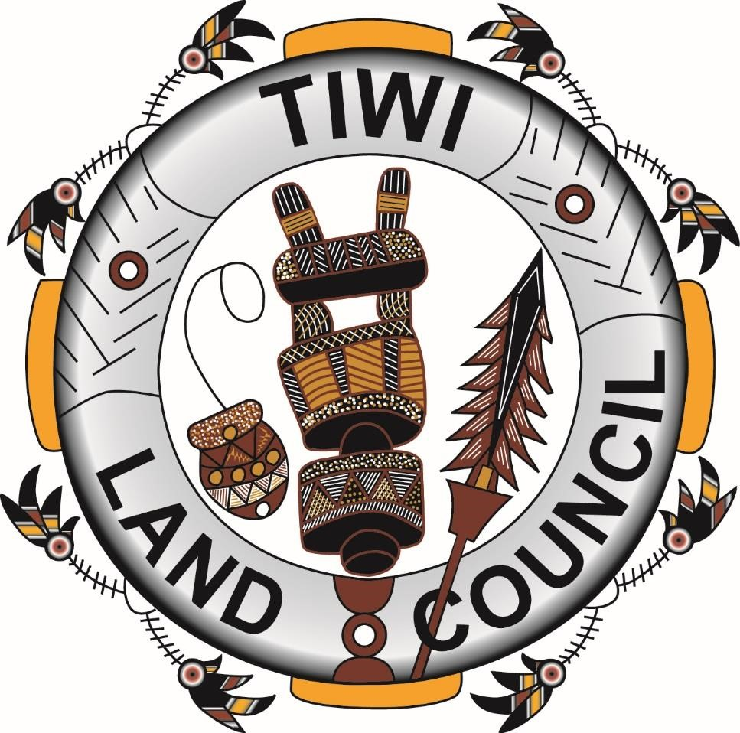

Corporate Plan

2019-2023

21 June 2019

Contents
1 Introduction 3
2 Purposes 3
2.1 Objectives, functions and role of Tiwi Land Council 3
2.2 Strategies and policies that Tiwi Land Council will follow to achieve its purpose 3
Strategy Traditional Owner Recognition 3
Strategy Managing Land -Sacred Sites 3
Strategy Managing Land -Mining 4
Strategy - Education 4
Strategy – Communication 4
Strategy – Private Economy 4
3 Environment 5
3.1 Accountable authority 5
3.2 Land held in Trust 5
3.3 Traditional owners’ roles 5
3.4 Tiwi population 6
4 Performance 8
4.1 Measures of performance 8
Strategy Traditional Owner Recognition 8
Strategy Managing Land -Sacred Sites 9
Strategy Managing Land -Mining 10
Strategy - Education 11
Strategy – Communication 12
Strategy – Private Economy 14
4.2 Financial Projections 15
4.3 Schedule of planned evaluations 16
5 Capability 16
6 Strategic Assessment of the Operating Environment 17
7 Risk Oversight and Management 20

Introduction

We, as the accountable authority of Tiwi Land Council, present the 2019 - 2020 Tiwi Land Council corporate plan, which covers the periods of 2019-2023, as required under paragraph 35(1)(b)/95(1)(b) of the Public Governance, Performance and Accountability Act 2013.

Purposes

Objectives, functions and role of Tiwi Land Council

The Tiwi Land Council’s purpose is to enable the Tiwi to acquire and manage land and promote economic and community development. Tiwi Land Council will take a more pro-active in the services it offers to Tiwi people.

Strategies and policies that Tiwi Land Council will follow to achieve its purpose

Tiwi Land Councils have important functions in relation to Aboriginal land.
We are committed to ensure that Land Council act on the advice and with the consent of the traditional owners so that primary control over Aboriginal land lies with the traditional owners.
This process may lead to enhancements of the following strategies and policies.

Strategy Traditional Owner Recognition

Tiwi Land Council under its budget estimate has requested to engage an anthropologist.

Strategy Managing Land -Sacred Sites

Tiwi Land Council will continue in their assistance in the protection of sacred sites and areas of significance both on land and in the sea.

Strategy Managing Land -Mining

Traditional owners will be sought to express their wishes, in accordance with the Aboriginal Lands Rights (Northern Territory) Act pertaining to the issuance or otherwise of exploration leases on Tiwi Aboriginal Land Trust land.

Strategy - Education

Public Governance, Performance and Accountability Act 2013

The Accountable Authority of Tiwi Land Council is stated as the Chair and the CEO. The Tiwi Land Council through the Chair and the previous CEO and prior to the commencement of the Public Governance, Performance and Accountability Act 2013, (PGPA Act) expressed a view that the Accountable Authority of the Tiwi Land Council would consist of the Chair, Deputy Chair and eight other members of the Land Council, known as a committee,
Executive Management Committee, of the Tiwi Land Council. Going forward this concept will be articulated further.

Aboriginal Land Rights (Northern Territory) Act 1976

The Executive Management Committee of the Tiwi Land Council undertakes development on land council governance matters;

Strategy – Communication

In order that the Tiwi Land Council can prioritise and perform its functions in a timely manner it has identified communication and transparency of such in its dealings as a priority.

Strategy – Private Economy

With the Tiwi private economy developing into independently operations, the focus of the Tiwi Land Council on these enterprises has moved from the preliminary assistance of negotiation of leases and licences, to assisting those commercial activities that will best deliver long term economic and social benefits to Tiwi’s in the development and the total Tiwi population.

Environment

Accountable authority

The Accountable Authority consists of the Chair and CEO. The tenure of these positions is:
Chair, Mr Gibson Farmer Illortaminni, was elected for a three-year term in February 2018 so the term will conclude in February 2021. This is the third term of the Chair and stability of the position continues.
The CEO, Andrew Tipungwuti, was successfully appointed for a three-year term on the 2nd August 2018.

The Minister has provided for a position of General Manager to assist and capacity, build Mr. Andrew Tipungwuti to the position of CEO. This position has been included in the budget estimate for the following 3 years.
Accountable Authority

 | 2019-2020 | 2020-2021 | 2021-2022 | 2022-2023
Chair |  | Election year
CEO

Land held in Trust

The Tiwi Aboriginal Land Trust has grown with an additional area known as the Vernon Islands to be included in schedule 1 of the Aboriginal Land Rights (Northern Territory) Act 1976. The Vernon Island has an Exploration permit application EP295.

Traditional owners’ roles
By virtue of section 23 (3) of the Aboriginal Land Rights (Northern Territory) Act 1976, a Land Council is obliged, in carrying out its functions with respect to any Aboriginal land in its area, to have regard to the interests of, and consult with the traditional Aboriginal owners of the land and any other Aboriginals interested in the land. Furthermore, the Land Council is prohibited from taking any action in any matter in connection land held by a Land Trust, including the giving of consent or the withholding of consent, unless the Land Council is satisfied that:
(a) the traditional Aboriginal owners of the land understand the nature and purpose of the proposed action and as a group, consent to it; and
(b) any Aboriginal community or group that may be affected by the proposed action has been consulted and has had adequate opportunity to express its view to the Land Council.
Another relevant provision of the Aboriginal Land Rights (Northern Territory) Act 1976 is section 29, which deals with membership of a Land Council. It provides that members of a Land Council shall be Aboriginals living in an area of the Land Council or whose names are set out in a register maintained by allowing Council in accordance with section 24, who are chosen by Aboriginals living in the area of the Land Council in accordance with such methods as approved from the Minister, section 29(1).
The significance of these provisions lies in the fact that the Aboriginal Land Rights (Northern Territory) Act 1976 makes clear that only Aboriginal people are entitled to be members of a Land Council. Moreover, the Aboriginal Land Rights (Northern Territory) Act 1976 enfranchises Aboriginal people in the process of electing members of a Land Council.

Tiwi population

The Tiwi Islands of Bathurst and Melville Island consists of approximately 7,000 square kilometres with 3000 people, 2011 and 2016 ABS Census data provide a slightly lower figure than this limit. Differences are accounted for with children been educated in Darwin and interstate, Tiwi’s away from Island, undertaking employment training and development and those visiting family and friends predominately in Darwin. Historically the death rate had averaged at 40 people per year, 2018-2019 saw an average rate.
Populating the Vernon Islands is not planned, leaving the townships on Bathurst and Melville Island the major population centres.
There is a significant interest in people returning to their homeland. ABA homeland funding project provides a one-off infrastructure investment in selected homelands to improve living conditions.

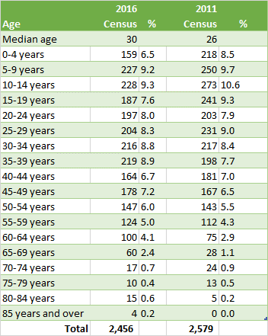

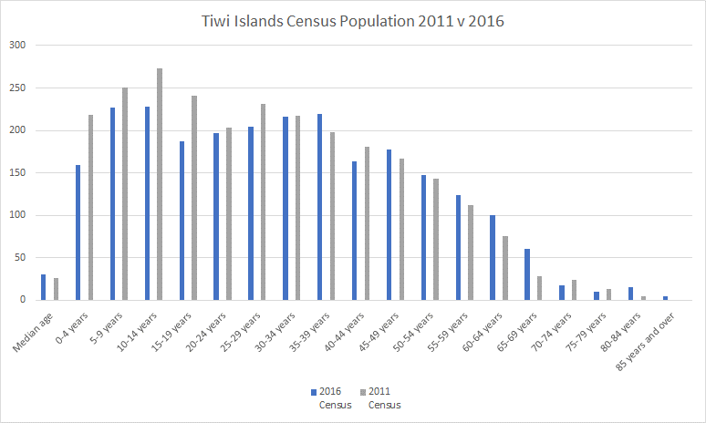

As the Tiwi private economy grows, the number of non-Tiwi in the form of fly in fly out workers has increased. The private economy service enterprises have the capacity to accommodate these additional works, without encroaching on the housing stock or diminishing infrastructure assets available for the Tiwi’s.

Performance

Measures of performance

Strategy Traditional Owner Recognition

Tiwi Land Council under its budget estimate has requested to engage an anthropologist. There are two areas that an anthropologist will assist the Tiwi.
Firstly, collecting information and stories of senior living community members pertaining to the role and connection of Tiwi on land in and around Gunn Point, Tree Point, Darwin and land South East of Darwin.
Secondly, in seeking information about Tree Point, the anthropologist will work close with the Mantiyupwi clan and be required to communicate with Durduga Tree Point Aboriginal Association Incorporated. Mantiyupwi clan will also need to take direction on their options in securing land at Tree Point currently held by Durduga Tree Point Aboriginal Association Incorporated.
- Section 3104, Hundred of Bagot is owned as freehold title by the Durduga Tree Point Aboriginal Association Incorporated.
- The title is prescribed property and as such any dealings on the land need to be in accordance with Section 110 of the Associations Act. In short, this means that consent of the Attorney-General is required for actions such as the transfer, lease or mortgage of the land.
- The land was first granted in 1988 to the Tree Point Aboriginal Association Incorporated. At the time of the grant Margaret Munawee was President of the Association and John Samuel Baird was Chairman.
- In 1992 the Tree Point Aboriginal Association Incorporated changed its name to the Durduga Tree Point Aboriginal Association Incorporated.
- The Northern Territory Government does not have a list of the current members of the Association.
- The land is currently zoned CN (Conservation) and A (Agriculture) in accordance with the Northern Territory Planning Scheme. See attached map.
- The surrounding land is owned by the Conservation Land Corporation (Tree Point Conservation Area), David and Aileen Jan (Section 3103) and the Anictomatis family and Dennis Bradshaw (Section 3102).

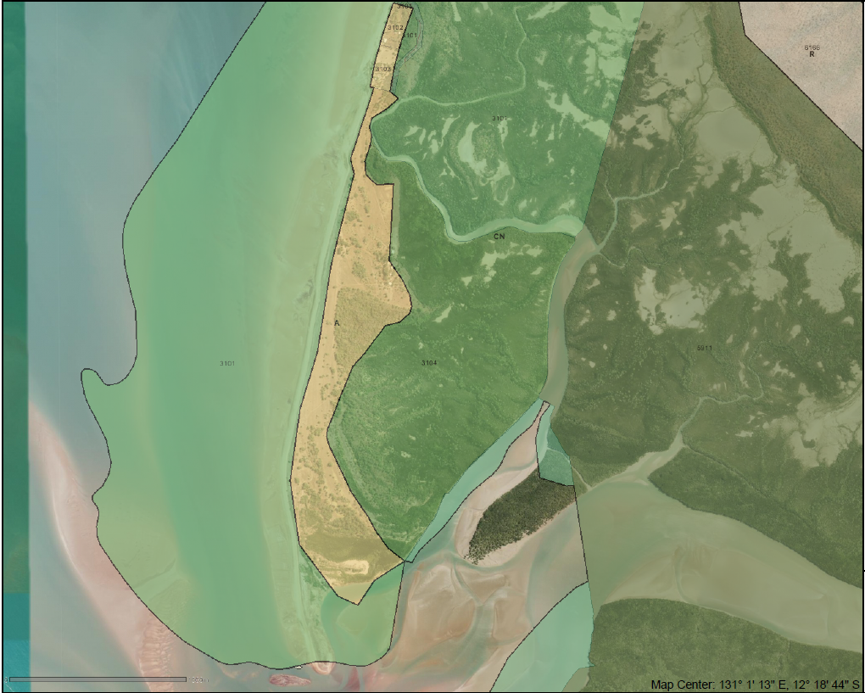

Strategy Managing Land -Sacred Sites

Tiwi Land Council will continue in their assistance in the protection of sacred sites and areas of significance both on land and in the sea. Most of the land under title of the Tiwi Aboriginal Land Trust is subject to mining exploration applications, with the entire area under title subject to a petroleum exploration permit application, continuing determination and consultations with traditional owners pertaining to sacred sites and significant areas will be undertaken. As mapping technologies improve and become operationally viable better use of them will be made.

Strategy Managing Land -Mining

Traditional owners will be sought to express their wishes, in accordance with the Aboriginal Lands Rights (Northern Territory) Act pertaining to the issuance or otherwise of exploration leases on Tiwi Aboriginal Land Trust land.
Concentration of attention will focus on negotiation of Exploration Licence Application 27644, the area bound in blue below. The applicant, Rio Tinto Exploration Pty, with an area under application consists of 425 blocks. Yimpinari land owning group, will consider matters under application and associated opportunities pertaining to with mining services. Formal negotiations will continue and are scheduled to continue in the latter half of August 2019.
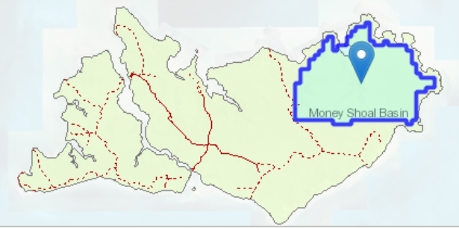

During 2019 there has been a significant increase in the number of interested parties seeking to undertake sand mining on the Tiwi Island, with a focus on the southern coast line of Bathurst Island.
A few of the proponents have been better prepared than the majority, although difficulty is encountered when asked how the Tiwi will benefit from such sand extraction and how they would interact with the MZI Resources Limited.
MZI Resources Limited appointed, on the 16th April 2019, McGarthNicol Restructuring as Voluntary Administrators. Thus, the following Exploration Licences are held by MZI Resources Ltd (100%), Agent McGarthNicol Partnership;
- EL24329, highlighted with blue boundary below, consisting of 28 blocks; and
- EL24851, highlighted with thin green line below, consisting of 12 blocks.
the associated purpose of the exploration licence is of mineral sands, rather than of sand mining.
Tiwi land Council will investigate opportunities for the potential transfer of exploration licences to the Tiwi’s for the purpose for owning their exploration licences and potential mining associated with this opportunity.

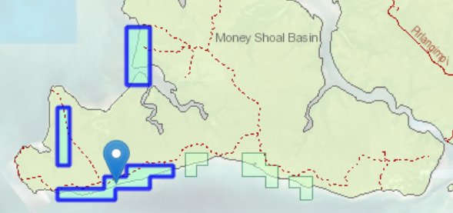

Strategy - Education

Public Governance, Performance and Accountability Act 2013

The Accountable Authority of Tiwi Land Council is stated as the Chair and the CEO. The Tiwi Land Council through the Chair and the previous CEO and prior to the commencement of the Public Governance, Performance and Accountability Act 2013, (PGPA Act) expressed a view that the Accountable Authority of the Tiwi Land Council would consist of the Chair, Deputy Chair and eight other members of the Land Council, known as a committee,
Executive Management Committee, of the Tiwi Land Council. Going forward this concept will be articulated further.
The Tiwi Land Council has received training funds under the current year budget and meeting fees allowing for an increase in number of meetings than was undertaken prior to the introduction of the PGPA Act.
In hopeful anticipation of recognition of the Executive Management Committee, the ten members including the Chair, Deputy CEO, and the CEO are developing an appreciation of the duties of an accountable authority and the manner which an accountable authority is to operate.
Duties identified by the Executive Management Committee which must be undertaken by an accountable authority are;
- govern the Tiwi Land Council in a way that promotes the proper use and management of public resources; the achievement of the purposes of the Land Council; and the financial stability of the Land Council, considering the effect of decisions on public resources generally;
- maintain and establish appropriate risk oversight and management of the entity; appropriate systems of internal control; and ensure officials comply with finance law;
- encourage officials of the entity to cooperate with others to achieve common objectives;
- when imposing requirements on the use or management of public resources, consider the risks associated with this, and the effects of, imposing those requirements;
- keeping the responsible Minister and the Finance Minister informed of the activities of the Land Council;
- taking all reasonable measures to prevent, detect and deal with fraud relating to the Land Council.
Staff as officials of the Tiwi Land Council are been informed of these duties.

Aboriginal Land Rights (Northern Territory) Act 1976

The Executive Management Committee of the Tiwi Land Council undertakes development on land council governance matters;
Current attention is committed in seeking the method of choice for membership of the Tiwi Land Council been approved. The method of choice prepared by the Tiwi Land Council recognises traditional decision making of the Tiwi people.
Tiwi Land Council may delegate its functions and decision-making powers in accordance with the Aboriginal Land Rights (Northern Territory) Act 1976, to the Chair or another member of Council, a member of staff, a committee appointed under section 29A.
Governance arrangements include a Full Land Council and an Executive Committee which sets policy and makes decisions of its functions under the Aboriginal Land Rights (Northern Territory) Act 1976.
Tiwi Land Council is committed within six months of approval of the method of choice, to commence reviewing the delegations and governance arrangements of the Full Land Council and the Executive Committee.

Strategy – Communication

In order that the Tiwi Land Council can prioritise and perform its functions in a timely manner it has identified communication and transparency of such in its dealings as a priority.
Communication requires that the Tiwi Land Council is actively involved in the community expressing its function and roles and seeking feedback and intentions of Traditional Owners.
The remote nature of the island and the extremely limited communication infrastructure places additional pressure on Land Council members.
A planned upgrade of electricity infrastructure of an inter and intra islands nature, is still in the planning stage.
Darwin Tiwi Land Council Office, 116 Reichardt Road, Winnellie was officially open by the Minister for Indigenous Affairs on the 10th May 2019.
Tiwi’s have chosen this property due to its accessibility to public transport, enabling Tiwi wishing to make any inquires or avail themselves to future services to be offered in an open and safe accessibility environment.
The new office property is also well located for meetings with various Government Agencies and Non-Government service providers.
It will provide a pleasant workplace for staff to perform their functions., with a new boardroom that will be a welcome relief for Executive meetings.
For the Land Council to articulate and express the needs, objectives, and traditional decision-making techniques of the traditional owners, its principle form of communication will be by direct personal communication.
Communication will take the form of formal land council and committee meetings, these meetings will effectively measure the level, breadth, and content of consultative and information gather meetings.
Information gathering, undertaken within consultative meetings framework, will predominately focus on the traditional decision-making techniques of the Tiwi.
Enhanced communication is expected to be developed with the introduction of the following positions, which have been identified by the Tiwi as value adding and consistent to their approach of land management;
- General Manager
- Receptionist Administration Officer
- Anthropologist Officer
- Resources and Environmental Officer
- Combined Principal Legal Officer/CFO
- Administrative Officer

August 2018 saw the launch of an enhanced website, with a fully integrated permit system. The site contains a wealth of information and is a useful resource for those seeking background information on the Tiwi Island and Culture.
The bi-monthly publication of ‘Tiwi News’ (also to be available on the website) will continue to assist the land council to communicate back to the wider community on Tiwi events that the land council has assisted in.
The information system, SharePoint, has been deployed, this should assist with the retention of information and increasing workflow through collaborative working projects. Further, digitisation of archived records, estimated to be 300,000 pages, is schedule for July 2019, which will bring the land council in line with the digitisation requirements by June 2020.

Strategy – Private Economy

With the Tiwi private economy developing into independently operations, the focus of the Tiwi Land Council on these enterprises has moved from the preliminary assistance of negotiation of leases and licences, to assisting those commercial activities that will best deliver long term economic and social benefits to Tiwi’s in the development and the total Tiwi population.
The structure, roles and responsibilities of these new business enterprises are introducing new corporate governance requirements, and concepts of individual responsibilities as opposed to community responsibility. To deal with these operation requirements, the Tiwi Land Council will endeavour to facilitate training and development on these matters by suitably qualified professionals and appropriate qualified advisors.
Income streams flowing from the private economy in the form of lease and royalty payments will be encouraged to be paid at times that will not lead to inference with children attendance at school, or to those that have demonstrated at least 80% school attendance of those children under their care.
Direct education is offered by the Tiwi Education Board at Tiwi College, a boarding school based at Pickartaramor offering education to year 12 level. The importance of on island education for the next generation, has seen the opening of a school at Ranku. Plans are to increase in student numbers. These centres of excellence will generate future leaders of the Land Council that a highly skilled.
Tiwi clan group that made investments in support of the Tiwi Plantations Corporation, are well positioned to receive their corpus in the coming years, whilst still receiving a return on their investment. Commonwealth government budget announcements include the allocation of $60m for seal roads on the Tiwi Islands, with the forestry operations to benefit from this process.
Tiwi Resources, Tiwi Resources Pty Ltd as Trustee for the Tiwi Resources Trust, have recently entered an arrangement know as, Tiwi Islands Savanna Burning for Greenhouse Gas Abatement, with the Indigenous Land Corporation for creating Kyoto Australian Carbon Credit Units through burning of the Tiwi’s land. This commercialisation of land and ranger interaction with the land, has seen a proposal made by the ranger program to sit entirely outside the Tiwi Land Council. A transition of all ranger programs to Tiwi Resources, is current underway, Tiwi Land Council’s request to transition the management of activity ID 4-96DHSJJ Tiwi Land Rangers and Tiwi Marine Rangers support 2021 to Tiwi Resources Pty Ltd, has been forwarded to PM&C legal division and we are currently awaiting advice on the approvals process dependent on wishes of the new Minister for Indigenous Australians.

Education
The method of choice is a mechanism in the appointment of trustee of the land trust and land council members. The Tiwi’s unique and consistent, with traditional decision-making techniques, method of selecting representatives to talk authoritatively about the land, is well documented. Therefore, it will be the Land Council’s responsibility to clearly articulate its method of choice to interested parties.
Land Council members are continuously seeking compliance with legislation, principles of good corporate governance, and are actively developing a decision register. Furthermore, in the coming financial year, review the written rules of convening and conduct of meetings and seeking approved by the Minister.
Land Council members are familiar meeting processes and communicate these to the other
Tiwi in order that an appreciation of the processes is understood;
- processes on convening meetings,
- defining what is a quorum of a meeting;
- confirm that a question is to be settled by a majority of votes of members present and voting; and
- circumstances when the presiding member has a casting vote;

Financial Projections

The Tiwi Land Council is funded from the Aboriginals Benefit Account (ABA). Budget estimates are prepared annually for administrative expenses and upon approval of the Minister for Indigenous Affairs are release quarterly to the Tiwi Land Council.
Tiwi Land Council has received other grants relating to activities within the land and sea management output group. These are for specific projects, some running across multiple years and generally delivered by external contractors and consultants.
The Tiwi Land Council shall not carry out any commercial activity quarantining itself from incurring any financial liability or enabling it to receive financial benefit.
The charging of fees for service, although permitted under regulations of the enabling legislation, is underutilised by the Tiwi Land Council. The Department of Finance has implemented the Australian Government Charging Framework, the schedule of portfolio charging reviews of the Prime Minister and Cabinet is in 2019-2020.
Forward projections are based on the premises; ongoing funds source of ABA;
- inflation rate Darwin CPI 1%
- 10-year Australian bond yield range of 2%.

 | 2019-2020 | 2020-2021 | 2021-2022 | 2022-2023
 | Estimate | Estimate | Estimate | Estimate
S64(1)
S64(1) | $5,355,780 | $5,333,350 | $5,524,441 | $5,634,929
Other Income | $6,000 | $6,000 | $6,000 | $6,000
Sub total | $5,361,780 | $5,339,350 | $5,530,441 | $5,640,929
Other Grants | 2019-2020 | 2020-2021 | 2021-2022 | 2022-2023
 | Estimate | Estimate | Estimate | Estimate
Settlement  Deed (Blue  Mud Bay) | $135,250 | $135,250 | $135,250 | $135,250
Sub total | $135,250 | $135,250 | $135,250 | $135,250
Total | $5,497,030 | $5,474,600 | $5,665,691 | $5,776,179

Schedule of planned evaluations

Collation of performance progress data is a continuous process that will allow for the easy assimilation of data annually to be produced in a timely manner that is accurate and reliable. Evaluation will be included in the annual report commenced in 2018-2019. Comparative figures will form part of the annual presentation.
Results will be numerically represented in reports, with sufficient analytical interpretation provided to ensure that where there are any changes to the purpose, activities or capability of the Tiwi Land Council or the environment which it operates in, sufficient information will be presented drawing the reader’s attention to these and the impacts and the implication of these matters moving forward.

Capability

Each of the eight land owing group, see below map, is represented by a Trustee and three delegates, these 32 represenatives form the memebers of the Tiwi Land Council. An Executive Management Committee is drawn from the Land Council, consisting of the Chair, Deputy Chair and eight Land Council members.
Staff enagaged to support Trustees and Land Council members include Chief Executive Officer, General Manager, Chief Financial Officer, Principal Legal Officer, Financial Manager, Registrar, Senior Administration Officer, Executive Officer, Receptionist with additional positions of Anthropologist, Resource and Environment Office, and Grant Writer requested for the 2020 financial year.
Land Council members, in conjunction with staff, will undertake individual clan meetings and consultations, on island and at the Darwin office. A two year focus on caputuring registrar information will be conducted at these meetings.

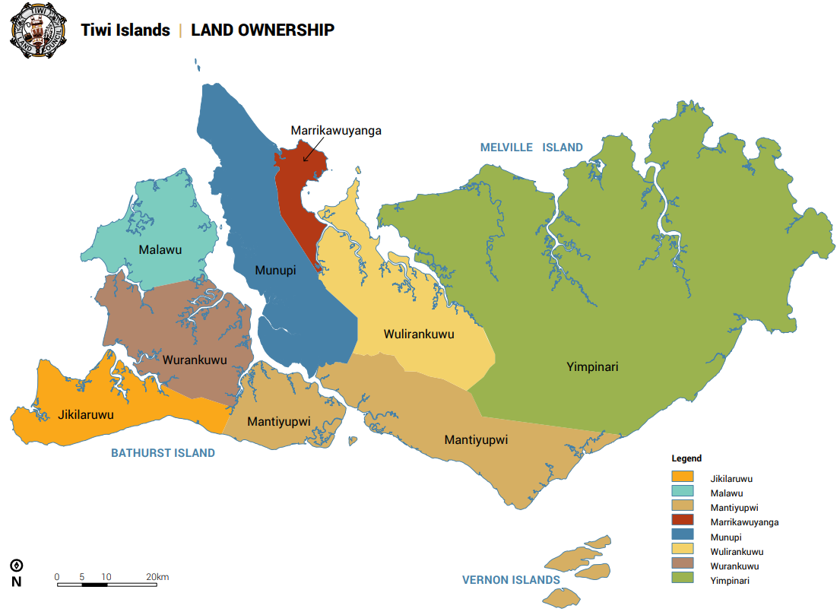

The island head quarters are based at Pickerataramoor, which are currently receiving additional infrastructure upgrades, 4G hub and dedicated bore facilities.
Digitisation of hard records and the use of Sharepoint, a cloud base solution, will allow access to appropriate records to Executive Management Committee and staff members on demand.

Strategic Assessment of the Operating Environment

Tiwi Land Council will need to meet these increasing expectations and deliver its outputs in a resource - constrained environment. Over the next four financial years, the Land Council’s budget is expected to increase in line with Consumer Price Index factor of Darwin. In this context, the department will need to continue to find efficiencies. Workforce decisions made during this period will have a critical impact on the Land Council’s capability and capacity in future years.
It is important to maintain current capabilities and to build new capabilities. Increased capability contributes to preserving overall organisational capacity.

Any reduction to budgets may also impact on the availability of training and development. As a result, there are risks for the Land Council’s overall capability.

Our capabilities | Sustaining and developing our capabilities
Deep understanding  Understanding the economic and policy environment, and the views of the Tiwi’s. | - Building a thorough and shared understanding of our identity, mission, value-adding role, priorities, and frameworks.  - Applying a whole of Tiwi economy approach to our advice and analysis.  - Understanding our policy environment and the viewpoints of traditional owners and stakeholders.  - Comprehending what policies are set  out to do, their alternatives, their impacts and their implementation.  - Establishing, maintaining, and using internal and external networks.  - Building economic, legal, accounting, and other technical expertise and capacity.  - Developing and maintaining corporate memory through developing procedural  manuals and effectively using knowledge and information management systems.
Collaboration  Collaborating with internal and external stakeholders to develop effective policy. | • Establishing and participating in forums to support and drive creativity and innovation.
Our capabilities | Sustaining and developing our capabilities
- Appropriately sharing knowledge and information across Tiwi organisations.
- Responding to stakeholder input.
- Building effective relationships with external stakeholders to influence policy directions.

Efficiency and productivity  Managing costs, allocating resources and enabling efficiencies. | - Improving output quality and system streamlining, including through managing knowledge, being flexible in the use of expertise, building skills and simplifying processes.  - Investing in data, systems, and technology to improve quantitative analysis across the Tiwi Land Council.  - Ensuring resource allocations are well informed, consistent with the Land Council’s mission and responsive to changing priorities, including risk management.

Risk Oversight and Management

Underlying Philosophy
The Tiwi traditional leaders have a strong collective determination to ensure the future wellbeing of their people based on the following principles:

Excellence in Education is the key for Tiwi to maximise economic sustainability and the social wellbeing of the Tiwi people.
The preservation of Tiwi culture and culturally respectful decision-making processes.
The sound commercial development and use of Tiwi major assets: the land, the surrounding seas, and the Tiwi workforce.

Indicator | Risk | Description of Risk
1. | Succession Planning | The leadership of the Land Council currently consists predominantly of men over the age of 60.  There are only a handful of Tiwi leaders in the next generation with sufficient education and knowledge of the laws and practices (Traditional and Western) to allow them to lead the Land Council in the future.
2. | Governance | External compliance with authorised Tiwi governance structures and threats to secure tenure of land and sea.  Internal threats to compliance with authorised Tiwi governance and emerging economic organisations.
3. | Undertaking financial obligations | The Land Council cannot legally take on commercial risks, including risks that could create related entities.
4. | Transparency of  financial distribution | Communication risks of client ignorance of financial management and lack of understanding and accurate, detailed knowledge of how money received by the Land Council is distributed. Resentments and unrest in the community that can be exploited by those who wish to undermine the authority of the Land Council.
5. | Participation: | The TLC has identified that lack of participation across all Tiwi drivers of political, social, and economic development is a major risk to the future and wellbeing Tiwi society. The disproportionately large cohort of Tiwi people aged 25 and under is a growing concern.
Indicator | Risk | Description of Risk
Lack of upcoming leaders and leaders being unaware of their roles and responsibilities.
Parenting:
Parents unsure of roles and responsibilities in being effective parents.
6. | Tiwi Plantations | Standalone major industry risk.  Environmental risks real and imagined.  Political risks of doing business and non-compliance with aboriginal industry and program norms.  100% Tiwi owned risks without external investment.
7. | Traditional Land Ownership: | Large numbers of people, currently in excess of 160, applying to be included in the Tiwi Register of Traditional Owners leading to confusion, resentment and unhealthy pressure on actual Traditional owners.  As the income of Tiwi land value increases so too does the demand from people applying to access that income.
8. | Land Use Funds | The Land Council is responsible to calculate and receive all funds from use of land and resources from the land. These funds generally require distribution from the Land Council within six months of receipt.  Amendment of the Land Rights Act now requires funds only be given to an organisation that can produce a set of financial accounts. In addition, the Land Council is obliged not to give money to organisations that it reasonably suspects are misusing that money.  Risk 1: The Land Use Funds must be taken and distributed in a timely fashion.  Risk 2: Land Use Funds must be allocated in accordance with legislative obligations.
9. | Asset control | There is a risk of loss of assets through negligence, fraud and misuse
10. | Monetary Fraud | The Tiwi Land Council has an annual budget of $5,497,030. There is a risk of loss of monies through fraud.

